*[Excerpt from a pre-print of "Programming with Python for Social Scientists"]*

# Getting Developer Access To Twitter APIs (and Building Your Own "AppCred.py"

Twitter APIs (and in fact, most APIs on any platforms) will require authentication in order to give users access. All that “authentication” means here is that Twitter needs you to “log in” via Python so that the platform can give you access to use the API. Think of it like you might use your Twitter account in an everyday way – you first need to log in, with a username and password, to be able to see your timeline, favourite a tweet, talk to friends, follow new people, see what’s currently trending and so on. Logging in is what let’s Twitter know it’s *you* that’s accessing the service, and the same principle applies here – authenticating your details sets up a connection between you and Twitter that you can then use to do various things with the platform (including using their APIs to do things like collect data). So, what’s going to follow is a step-by-step walkthrough of how exactly to get the necessary authentication details – this will include setting yourself up with a developer account with Twitter, and retrieving the correct “tokens” (i.e. user details) that Python is going to need[1].

###### Setting Up a Twitter Developer Account

First and foremost, you will need a Twitter account (and eventually, a valid phone number that hasn’t already been used with an existing Twitter account) – you can either use one you already have, or set up a new one, either will work, but for the purposes of this walkthrough I’ll talk about setting up a new account so that we can start from scratch[2]. So, if you’re setting up a new account, you’ll first need to visit the Twitter website (Twitter, 2019a) and click the button to “Sign Up” for a new account. At that point, you’ll need to input your name and either your phone number or an email address[3]. You will be asked at this point how you want to “Customise your experience” – you don’t have to do this, and since it’s not especially relevant for our present purposes, I’ll recommend to skip past it. You’ll then be asked to view and agree with the Twitter terms and conditions before clicking a button to “Sign up”. Depending on your chosen method of communication – phone or email – you’ll be sent a verification code; use that code to verify your account. There will then be a series of messages asking you to input a password, pick a profile picture, tell Twitter what sort of content you’re interested in, suggestions of who to follow and whether or not you want to receive notifications – you don’t have to do most of these, to keep pressing forward until you can see your new (empty) Twitter timeline. Congratulations, you’ve got yourself an account!

Now the next step: you need to use this account to sign into Twitter as a *developer* (rather than a user). To do this, visit the Twitter developer pages (Twitter 2019b) and sign in with your new details. Next, there is a menu along the top bar of this page called “Apps” – click that and you will be led to a screen that looks something like:

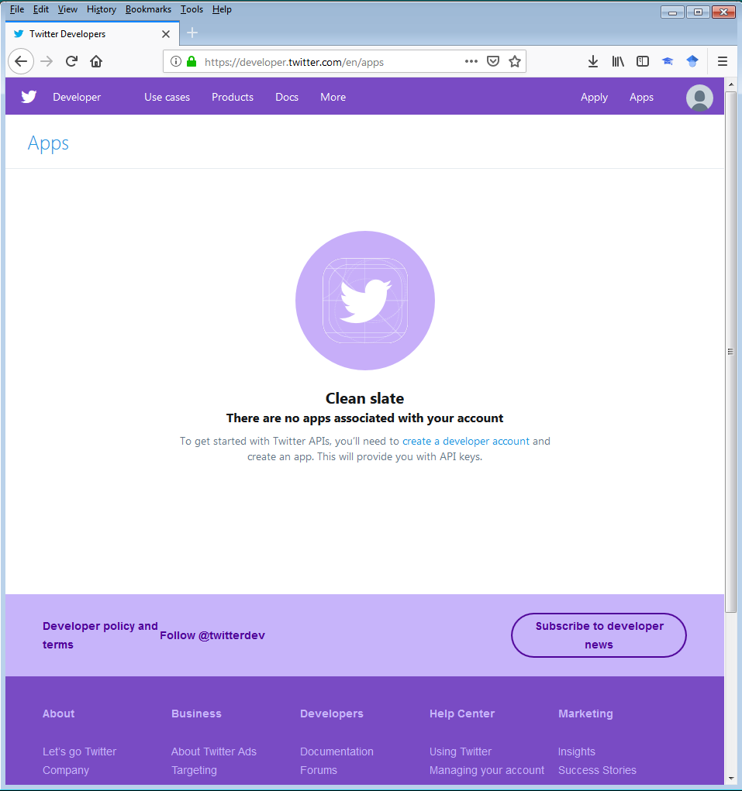

Figure 11. 1. Let’s make a Twitter app!

As Figure 11. 1. suggests, there are no apps associated with your account – we need to create an developer account in order to create applications. So, we can click on the link to do this, also visible in Figure 11. 1., and be met with something like the following screen:

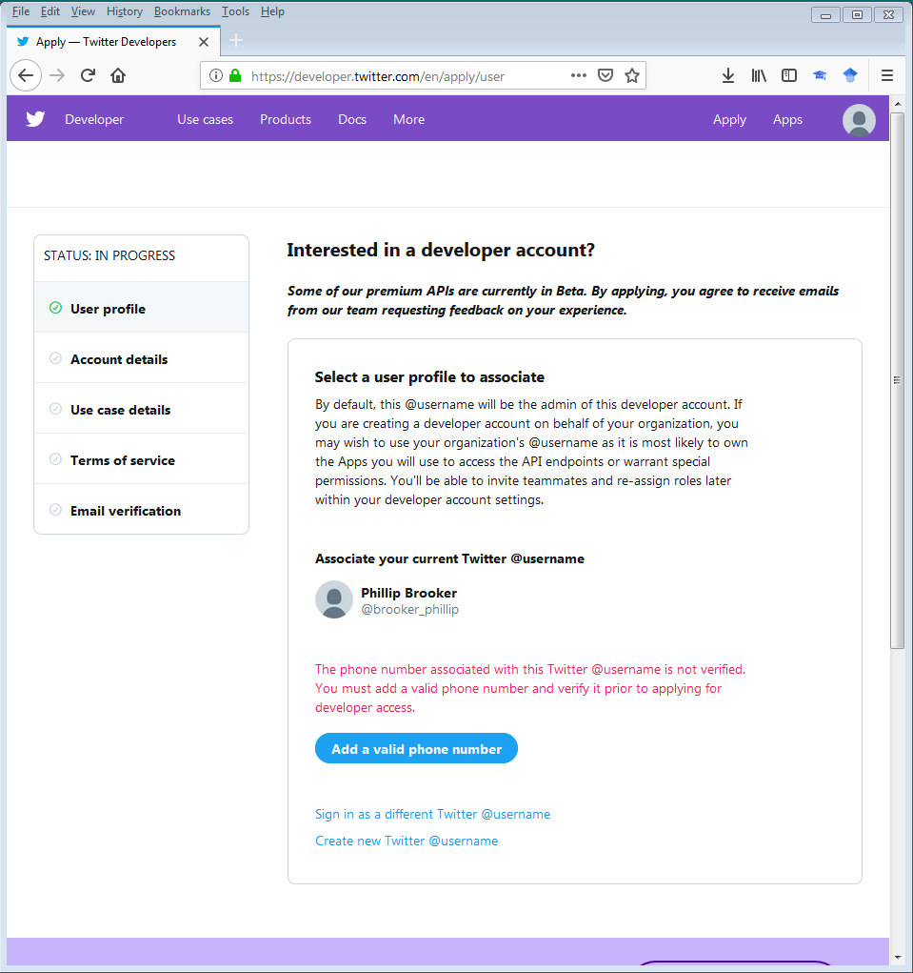

Figure 11. 2. Setting up a developer account

This is where we’re going to get access to Twitter as developers, but you might already note that we’re going to have to input some details – see the sidebar called “STATUS: IN PROGRESS” on the left of Figure 11. 2. – including a phone number that is not already associated with a Twitter account[4]. So let’s do that.

You will be asked to add in a valid phone number, and once you have done so you will be asked to provide a verification code which is sent to your phone via text.

You will also be asked to input some details about how you propose to use Twitter. You should take some time to read the documentation around this, all of which is presented on the page or via hyperlinks to other documentation (e.g. on “restricted use cases”). However, for our purposes, we are interested in only a selection of particular use cases, and not all of these should be selected (it depends on what you want to do with the Twitter APIs, and that’s for you to decide. Practically, the information in this chapter is going to cover a range of cases which may include collecting data from Twitter (in which case you might want to tick the “Academic research” and/or “Student project / Learning to code” boxes), or publishing content to Twitter perhaps in an automatic way (in which case you might want to tick the “Publish and curate Tweets” and/or “Chatbots and automation” boxes). Make sure you are *only* ticking the boxes that are relevant to the specific project you intend to work on with this account.

At this point, you are also asked to describe in your own words what you are building by providing text answers to a range of questions. You should be as clear as you can about your intended usage of Twitter and how you intend to avoid usages of the Twitter APIs that fall under their “restricted use cases” policies (hence the need to read the documentation carefully). Again, this has to be as clear and specific to your application as you can make it, so I’ll leave it to you to type out this text – my advice however is that aside from clearly describing your specific intentions with the Twitter APIs, do make sure to think about how you will avoid the “restricted use cases” (as indicated in the documentation also available on this same page) that might seem particularly relevant to your proposal. And below this text, you will be asked if your product, service or analysis make any information available to a government entity – select “No” here.

At this point, you will be asked to read the Terms and Conditions for usage of the Twitter APIs. There is lots of relevant and valid information in here so please do be sure to read it and even save a copy so you can refer back to it later. Once you have done so, check the relevant boxes to confirm you have done so and move on to the next section, upon which you will be informed that an email has been sent to the email address you have associated with the Twitter account in question – check your email to see if a request for verification has arrived, and if/when it does, click the link in the email to automatically verify your account. At that point, you will be presented with something like the following screen:

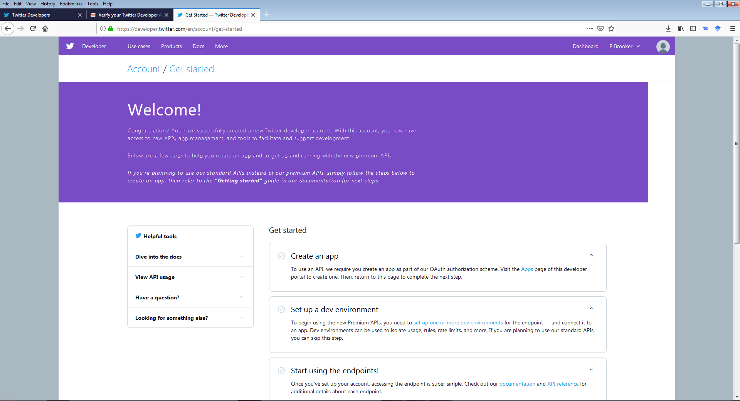

Figure 11. 3. Welcome, new Twitter developer!

Congratulations, you are now a Twitter developer!

###### Setting Up a Twitter Application

Now we’re set up as Twitter developers, we have some access to the Twitter APIs – great! However, we still need to create an application to get the necessary credentials through which we can have our Python script speak to the Twitter APIs to make legitimate requests; as noted at the start of this section, we need to make it so that our Python script can “log in” to Twitter so that Twitter knows who is making the requests, in the same way that we can’t tweet or read Twitter content as users unless we log into Twitter on the website or on the apps on our smartphones. So let’s create an app and find those details that we need.

On the top bar of the developer’s webpages, you will see the name you chose to link with your developer account – in Figure 11. 3., this is at the top of the image where it says “P Brooker”. Within that menu, you can select “Apps” and be taken to the following screen:

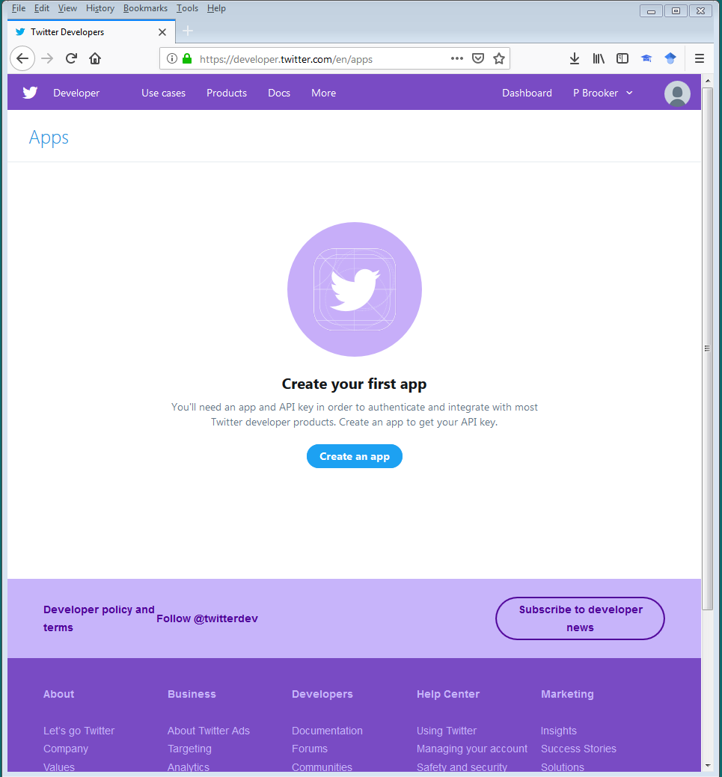

Figure 11. 4. New app time!

Click the “Create an app” button and fill out the details asked for in the form – you do not have to fill out all the fields here, and the ones that are required are “App name”, “Application description” (where you are expected to write a description between 10 and 200 characters), “Website URL” and “Tell us how this app will be used” (where you are expected to write information with a minimum of 100 characters). Focus on these fields only, and ignore the rest (at least for now), and click through to create the app, whereupon you will be taken to a screen which looks like...:

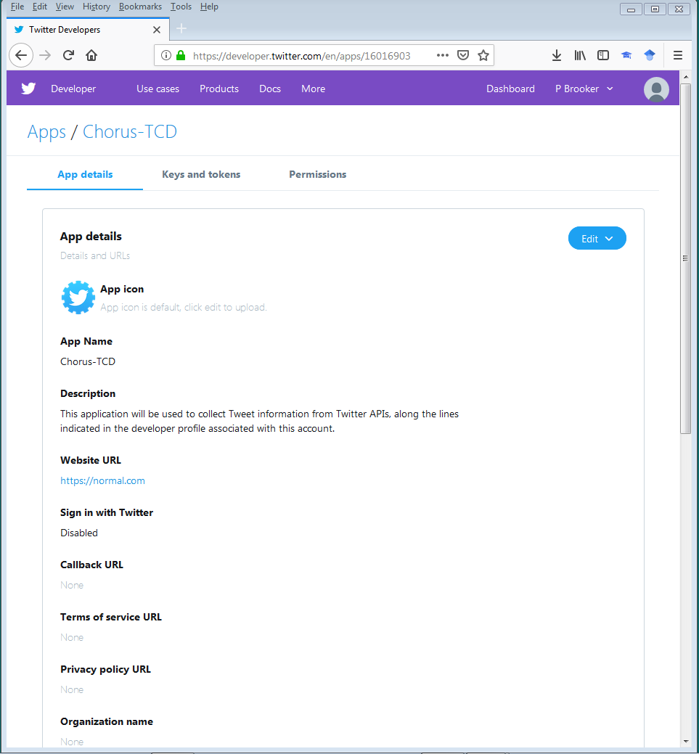

Figure 11. 5. Your new app!

###### Grabbing Your Application Credentials

Well done – you’ve created an app! Now let’s use it to generate the credentials we need to put in a Python script to authenticate our API access. To do this, click the “Keys and tokens” tab (visible in Figure 11. 5. above)[5] and you will be presented with two “Consumer API keys” – one string of text and numbers which is demarcated as the “API key” and one longer string of text and numbers which is demarcated as the “API secret key”. Create and open up a new Python script file called “AppCred.py”, and store the “API key” and “API secret key” as strings in variables as follows[6]:

CONSUMER_KEY = "INSERT API KEY HERE"

CONSUMER_SECRET = "INSERT API SECRET KEY HERE"

Next, we need to generate an “Access token” and “Access token secret” – back on the Twitter developer pages, we can do this by looking under the “Access token & access token secret” section of the page and clicking the “Create” button. This will generate two more lengthy strings of text and numbers, one demarcated as an “Access token” and one demarcated as an “Access token secret”. Copy these both over to your new “AppCred.py” Python script as strings stored in variables, as follows:

ACCESS_TOKEN = "INSERT ACCESS TOKEN HERE"

ACCESS_TOKEN_SECRET = "INSERT ACCESS TOKEN SECRET HERE"

You should now have a script which looks something like the following (I’ve added a couple of comment lines in the header to suggest that it’s probably also a good idea to have a reminder for ourselves what is actually contained in this script):

#AppCred.py

#My Application Credentials for Twitter APIs.

CONSUMER_KEY = "INSERT API KEY HERE"

CONSUMER_SECRET = "INSERT API SECRET KEY HERE"

ACCESS_TOKEN = "INSERT ACCESS TOKEN HERE"

ACCESS_TOKEN_SECRET = "INSERT ACCESS TOKEN SECRET HERE"

Excellent! This is all we need to start using Python to play around with Twitter’s APIs. However, it’s worth being really clear on this – **DON’T GIVE OUT THESE DETAILS TO ANYBODY ELSE!!!** Effectively, these are your login details, so it’s really really really really REALLY important that you keep these private – don’t store them in a shared drive or anywhere where their security might be compromised (e.g. over a cloud storage service). And in fact, this is exactly why we’re storing these details in their own little “AppCred.py” file – as we’ll see in the next section, we can import these details into a Twitter API script without having to write out our secrets as strings in full; this means we can share the Twitter API script with others, without having then to also share our authentication credentials. Now, all that remains to do is move your “AppCred.py” script to the location where you want to build a further Python script for exploring the Twitter APIs, because this is exactly what we’re going to go on and do next.

1. All of these details are correct as of the time of writing – 30/11/2018 – but of course, I can’t predict that these details and the Twitter website won’t change in the future. So, please treat the walkthrough as indicative of the steps that have to be taken and work through the process yourself with the details I give here as rough guidance.
2. I’m also going to talk about this whole process as if you’re doing everything on a desktop PC – you can of course set up a new Twitter account on other devices like smartphones or tablets, but given we’re working in the broader context of writing Python code on desktop machines, I’m going to stick to that path here too.
3. You won’t be allowed to use a phone number or email address that Twitter has already associated with another account.
4. If you are trying to set up a new Twitter account but have already used your phone number for another Twitter account, then I would suggest that you simply request developer access on your previous account already associated with your number.
5. I’m not going to give screenshots here, since this effectively would be the same as giving out my Twitter password publically. However, if you’re following along, the screen you’re currently at should be fairly obvious to interpret given my written description.
6. Be sure to use the same variable names as I have used here, for reasons which will become apparent below.